QUESTION
What is your ip-address?
what is your subnet mask?
What is your Network address?
What is your Broadcast address?

Committed by:- Aagaman K.C.
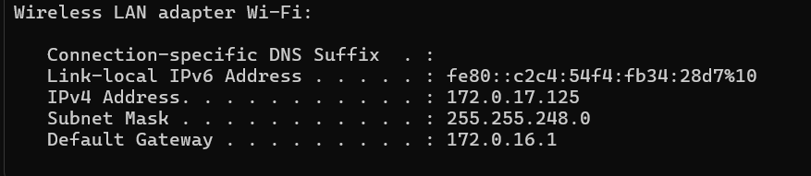
ip address → 172.0.17.125
subnet mask → 255.255.240.0
network address → 172.0.16.0
broadcast Address → 172.0.16.255
total n devices supported by my network → 2^8-2=254
(excluding address for broadcast and representing a network)

